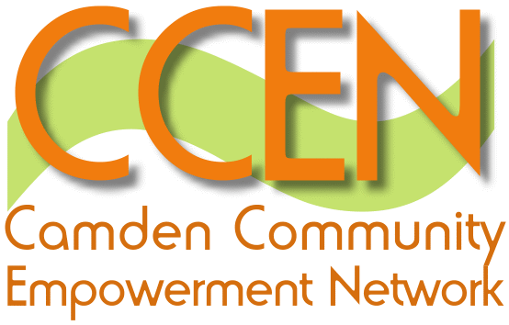

Giving White Paper

The Giving white paper published this week includes measures to make donating to charities easier (and increase it), and government funding for infrastructure, volunteering and supporting social action. There are a couple of new developments, notably support for local infrastructure lobbied for nationally by NCVO* and NAVCA**. The paper also reinforces some favourite government themes like reciprocity and philanthropy. Here’s an overview by chapter…..

Making it easier to give
- A number of initiatives under development to enable giving via ATMs, mobile phones and rounding up electronic bills to the nearest pound.
- Matching people who want to donate time or resources with organisations via electronic media and initiatives like social business Slivers-of-Time. The Social Action Fund will support self managed volunteering pilots to evaluate the market and assess potential.
- Better information. Youthnet (the Do-it website) are being supported to provide a national database of volunteering opportunities and make more use of social media like Facebook.
- Better philanthropy advice. Association of Charitable Foundations and the Community Foundation Network (CFN) are being funded to develop the Philanthropy UK service. As CFN pointed out this week 90% of donated money goes to less than10% of charities so hopefully they’ll be sorting that out.
- Removing barriers through changing CRB checking process, and making insurance for volunteer drivers easier to get. Citizen-led self regulation is also being explored (using website ratings like eBay and TripAdvisor).

Making it more compelling to give
- Inheritance tax reduction for people leaving 10% of estate to charity.
- Support for new models that facilitate reciprocity and build strong community – like time banking, local trading schemes etc.
- Match funding. The Community First Fund which has two elements: a £30 million Neighbourhood Matched Fund for deprived neighbourhoods. Communities will ‘match’ the funding with volunteer time, cash and in kind resources; a £50 million Endowment Match Challenge available throughout England with priority to build local endowments through philanthropic donations. These are intended to create a sustainable grant source for neighbourhood projects.
- Match funding for community campaigns – like the Evening Standard Dispossessed Fund.
- Giving will also be celebrated, encouraged as a cultural norm via schools, and rewarded (possibly with a peerage).

Better support for providers of opportunities to give
- Changes to Gift Aid. Include online filing system for charities to claim Gift Aid easily, raised ‘thank you’ gift limit (that’s if you want to give an in kind thank you to a donor – to the value of £2,500), and claiming Gift Aid type payments on small cash donations of up to £5,000.
- £30 million local infrastructure fund delivered by Big Lottery to improve support for frontline civil society organisations. The themes are development of efficient hubs to offer integrated support services, effective online resource bank, stronger local partnership with business and local statutory sector. The focus is on developing new services, redesigning existing ones, establishing new partnerships, alliances, shared provision, staff training for new roles, purchasing expert advice and support.
- Recognising need for volunteer management. E.g. use of Social Action Fund to train volunteer managers to support charities.
- Better digital capability. Martha Lane Fox has built the Race Online 2012 campaign to ensure everyone in the UK can use and access the web. 10,000 volunteers will be recruited as local digital champions to pass on IT skills to communities.
- Use of Government estate. Opening up government resources to charities e.g. use of government websites (Directgov.) and office space to support good causes.

You can download the Giving White Paper here.

