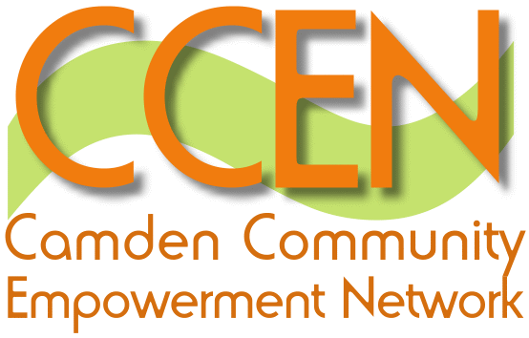

The Localism Bill was presented to Parliament in December and is now being scrutinised and debated by House of Commons committees. The Bill will provide the legislative foundation for the government decentralisation agenda – a shift of power from the state to communities. There are links to relevant information at the bottom of the page, but here’s a snapshot………

Local Government

- A General Power of Competence to give local authorities freedom to do anything as long as it doesn’t break other laws. Public bodies currently work within the confines of what legislation says they can do. This change is intended to give councils more freedom to work with others, innovate and drive down costs.

- Repeal of the Duty to Promote Local Democracy and the Petitions Duty (requires councils to have a mechanism in place for local people to submit petitions). These duties are seen as a burden on local councils and removal could save costs with little impact on frontline services.

Communities

- The Community Right to Challenge will give voluntary and community groups the right to express an interest in taking over the running of a local service if they think they can innovate or improve the service.

- The Community Right to Bid will require local authorities to keep a list of assets of community value. Communities will also be able to nominate assets they think are important. When assets on the list come up for disposal (freehold or long leasehold) a moratorium will come into effect to give community groups time to develop a bid and raise the money to buy the asset.

The planning system

- Neighbourhood planning. The Bill will introduce a new right for communities to draw up a ‘neighbourhood development plan’. Communities will be able to grant full or outline planning permission for developments that they want. Local authorities will be required to support neighbourhood planning through giving advice and technical support. In a recent speech Greg Clarke (Minister for Decentralisation) stated that government will be providing support to local authorities to make neighbourhood planning a success. In addition voluntary and community sector groups will be able to make bids on a fund to support communities in the planning process.

- The Community Right to Build will allow groups of local people to take forward new development in their area with a minimum of red tape. Proposals would need the agreement of local people through a community referendum. Benefits from the development would be retained for the community and managed by a corporate body formed by community members.

- There will be a requirement to consult communities before submitting very large planning applications. This is intended to give people a chance to comment and genuine scope to make changes to proposals.

Housing

- Social housing tenure reform will allow social landlords to grant fixed length tenancies from a minimum of two years. Those who currently have lifetime tenancies will be able to keep them and councils will still be able to offer lifetime tenancies if they wish.

- Reform of homelessness legislation will let local authorities meet their homelessness duty by providing private rented homes. People owed the homelessness duty would no longer be able to refuse suitable offers in the private sector and be temporarily housed until social housing becomes available. This is intended to stop people who may only have an acute short-term housing need acquiring a social home for life.

You can find the Plain English Guide to the Localism Bill along with the impact assessments on the different reforms here (scroll to bottom of page for document list).

To look at progress through parliament click here

